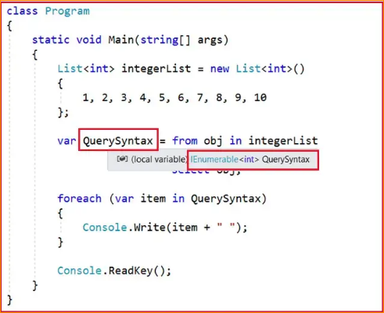

In the above example, we use the var keyword to create the variable and store the result of the LINQ query. So let’s check what is the type of the variable. In order to check this, just mouse over the pointer onto the QuerySynntax variable and you will see that the type is IEnumerable<int> which is a generic type. So it is important to understand what is IEnumerable<T>.

So in the above example, instead of writing the var keyword, you can also write IEnumerable<int> and it should work as expected as shown in the below example.

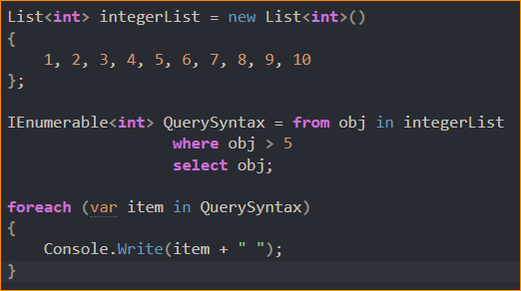

IEnumerable is an interface that is available in System.Collection namespace. The IEnumerable interface is a type of iteration(looping) design pattern. It means we can iterate on the collection of the type IEnumerable. As you can see in the above definition, the IEnumerable interface has one method called GetEnumerator which will return an IEnumerator that iterates through a collection.

The IEnumerable interface has also a child generic interface i.e. IEnumerable<T>. Let’s see the definition of the IEnumerable<T> interface.

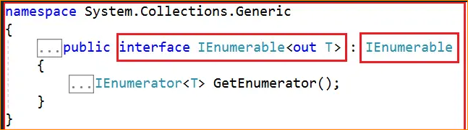

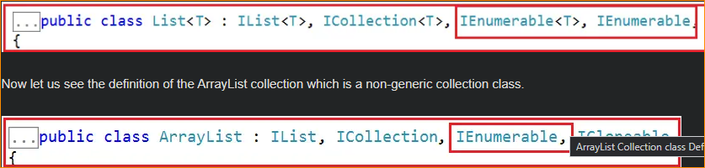

Ex-

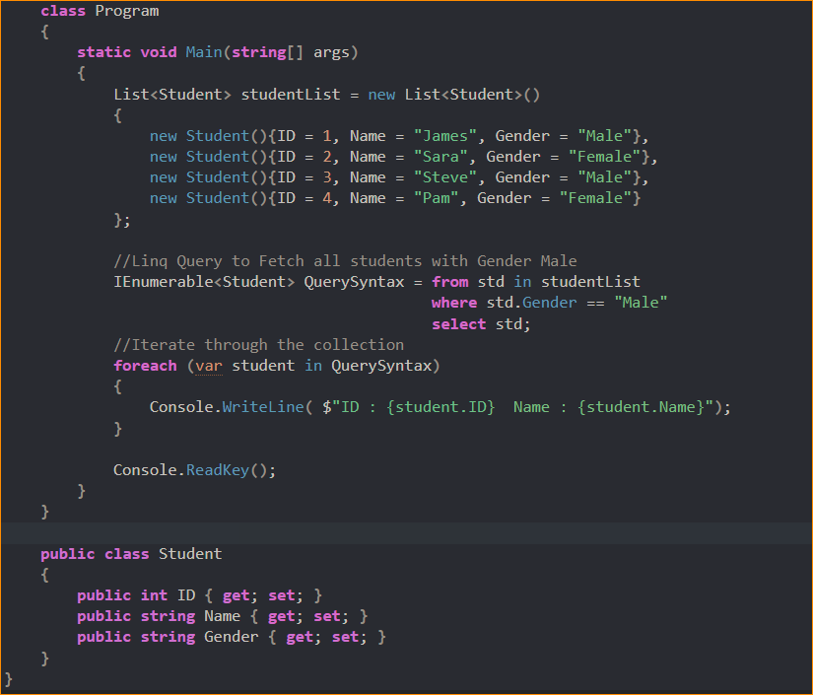

What is IQueryable in C#?

the IQueryable is an interface and it is available in System.Linq namespace. The IQuerable interface is a child of the IEnumerable interface. So we can store IQuerable in a variable of type IEnumerable. The IQuerable interface has a property called Provider which is of type IQueryProvider interface. Let us see the definition of IQueryProvider.

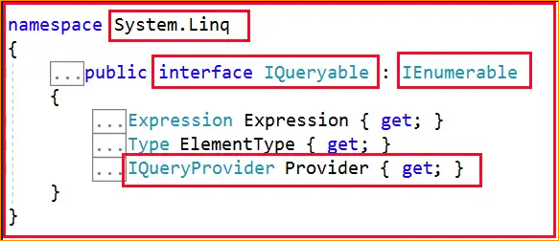

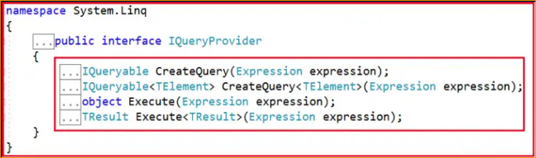

This IQueryable basically use for database iteration

Ex-

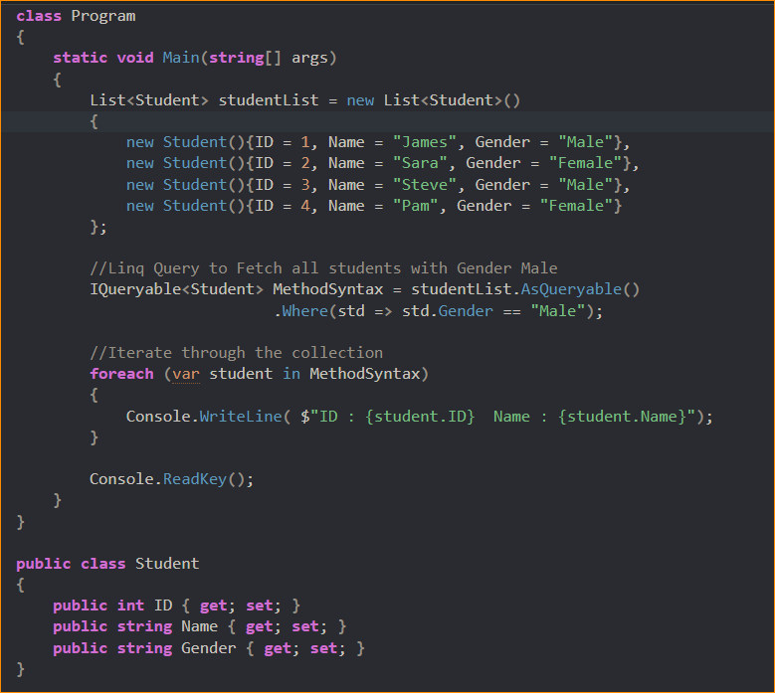

Both Use in One Programming –

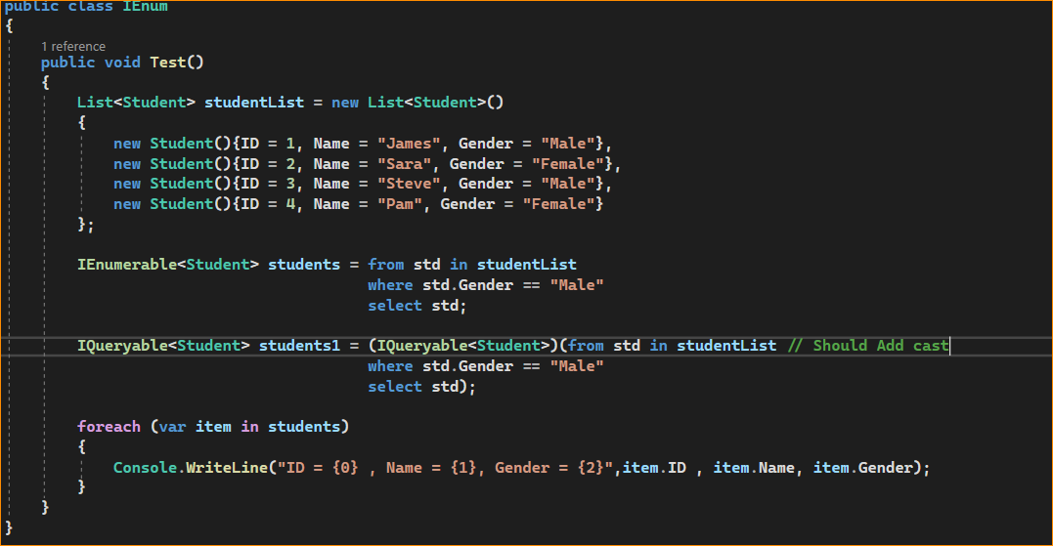

Which I Fast?

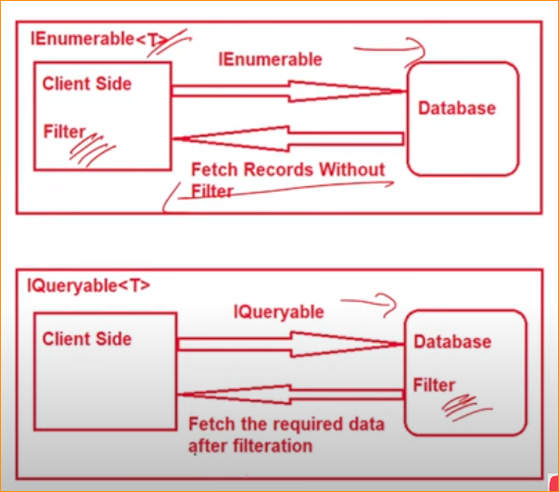

IEnumerable – First the request will go to the database and bring the ‘hole data from the DB and filter the result in the server side. Bring the hole data mean performing the negative.

IQueryable – Filter data in the database and send the faltered data to the cliend side